
Research & Vehicle Technology
“Infotainment Systems Product Development”

Feature – Illumination Management

APIM Infotainment Subsystem Part Specific Specification (SPSS)

Version 1.0
UNCONTROLLED COPY IF PRINTED

Version Date: May 31st, 2013

FORD CONFIDENTIALF

Revision History

Date | Version | Notes
 | 1.0 | Initial Release
Table of Contents
Revision History 2
1.1 Functional Definition 4
1.1.1 ILLMGNT-GFUN-293948-1-Day/Night Mode 4
1.2 Appendix: Reference Documents 6

Functional Definition

ILLMGNT-GFUN-293948-1-Day/Night Mode

Requirements
ILLMGNT-GREQ-293947-1-Scope of Day/Night Mode (HMI) -
only colours/textures Sshall change. Screen elements shall not move around or change size , nor even drastically change “appearance.” The intended effect is similar to turning on the lights in a dim room, or a city skyline photographed during the day and at night; everything looks the “same,” just lighter or darker, or more/less illuminated or similar idea.
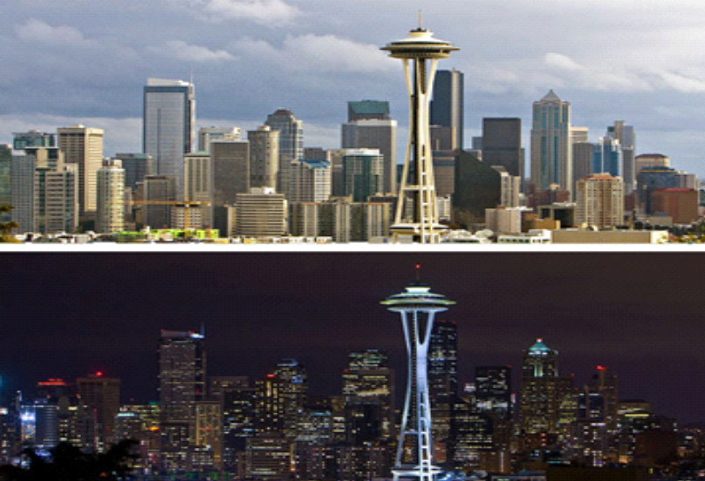
Photo copyright James MacLennan. All rights reserved

ILLMGNT-GREQ-293949-1-Affected Graphics (HMI) -
In order to accomplish this, all graphics will be affected and must be CAPABLE of change:
- System bezels and corner tabs
- System background (this will drive the need for the rest to change)
- Text
- Common component graphics
- Static page graphics

Fig. 1 Example day/night buttons from A21 GUI Design Standards. Note how system background, text and graphics all change

MY09 Next-Generation Navigation Radio  (Ford Daytime – white system background) | 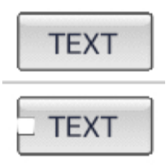
MY09 Next-Generation Navigation Radio  (Ford Nightime – black system background) | 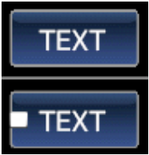

ILLMGNT-GREQ-293951-1-Day/Night vs. Themes (HMI) -
Day/Night is NOT the same thing as a theme. Day/night are sub-themes. i.e. every theme has a day and night variant. The implementation (of day/night and themes) may or may not be similar. The biggest difference requirements-wise is that Day/Night mode MUST switch on-the-fly within strict timing limits. By contrast, theme changes may involve re-starting the HMI if an on-the-fly theme-change solution is unacceptable.

ILLMGNT-GREQ-293957-1-Change shall occur on-the-fly (Performance) -
Day/night graphics changes shall occur on-the-fly on the currently visible screen.

ILLMGNT-GREQ-293958-1-Visible screens shall change first (Performance) -
For fastest response time, if multiple screens are resident in memory, the visible screen(s) shall be changed first.

ILLMGNT-GREQ-293968-1-All graphics shall change simultaneously (HMI) -
All graphics visible on the display shall change simultaneously . Note this does NOT mean “instantaneously”. A subtle animation between day/night is desirable (fade-through or similar).

ILLMGNT-GREQ-293970-1-All graphics shall be capable of day and night variants (HMI) -
All graphics shall be capable of day and night variants, but the system shall not force both variants to exist in all cases.

ILLMGNT-GREQ-294008-1-Use Single graphic as much as possible (HMI) -
As much as possible, a single graphic shall be designed to work for both day/night variants, for example by adding a dark stroke around light-coloured graphics that outlines it on light day background but largely disappears against the dark night background, leaving the light-coloured graphic clearly visible against the dark night background. Individual day/night variants shall be used only where this cannot be achieved in an aesthetically pleasing way.

ILLMGNT-GREQ-294010-1-Single graphics and day/night variants coexist (HMI) -
Day/night and non-varying graphics can coexist anywhere in any combination and differently per theme (i.e. any individual graphic can have a day/night variant in one theme but in another, consist of a single graphic that works in both modes or vice-versa).

ILLMGNT-GREQ-294011-1-Code abstraction (HMI) -
Code and graphic structures that executes the day/night change shall be abstracted into the HMI framework, base classes, widgets, graphic libraries and as few standard graphical implementations as possible. This shall be done in such a way as to allow the system to still differentiate between (the day/night graphics contained in ) views visible on screen and those which may exist in memory but are not currently visible to the user.

Appendix: Reference Documents
Reference # | Document Title
1 | CGEA 1.3 Illumination specification(s)
2 | CGEA 1.2 Illumination specification(s)
3 | C1MCA Illumination Specification(s)
4
5
6
7
8
9
10
11

